Shemakes.eu Participant Data Consent Form
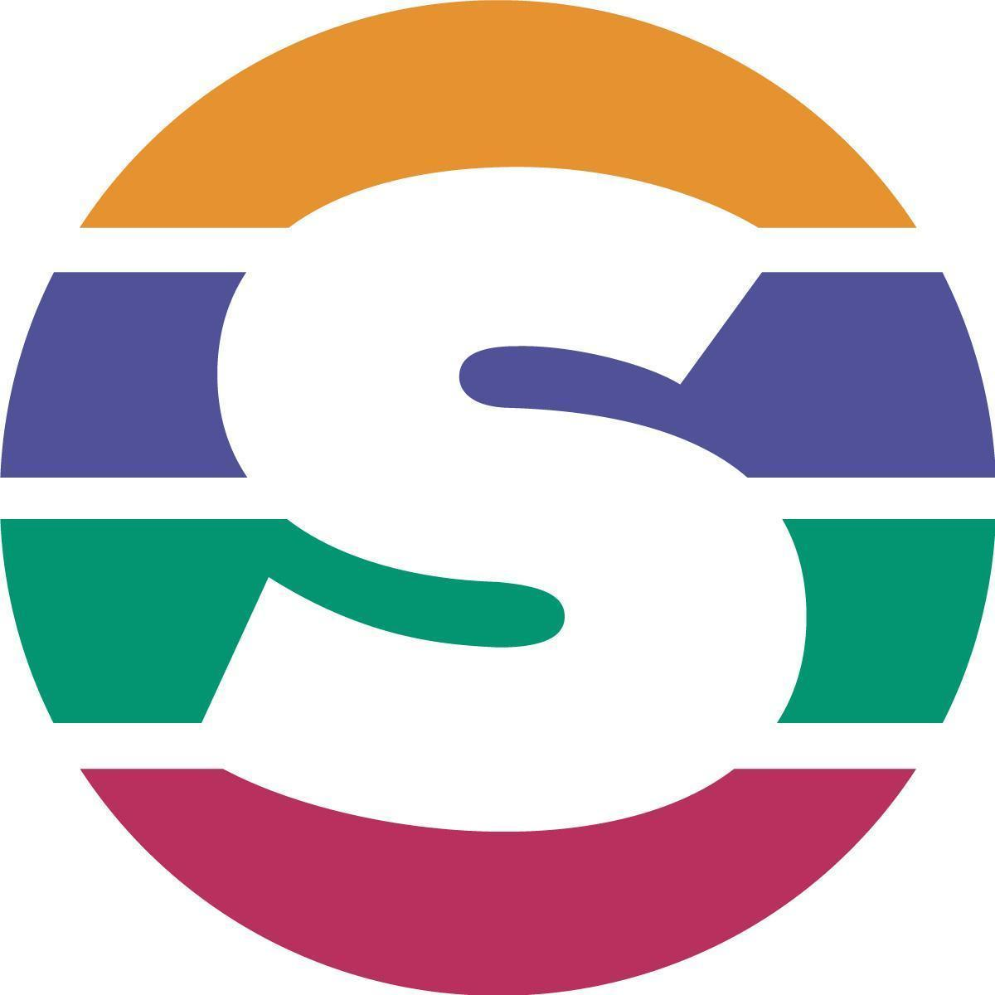
Shemakes.eu Innovation Narratives Survey

Goal of the survey | Short description  An online survey to collect information about female innovators, their profile, opinion on gender and how innovation plays a role in their career. The information collected will help the research to improve and better frame the innovation path of Shemakes.eu project.
Responsible person for the execution of the survey | Shemakes beneficiary name  Makesense
Data Protection Officer | Marco Cusenza  info@shemakes.eu
The aforementioned shemakes.eu beneficiary ensures that all data collected from participants is used exclusively for the purpose of managing and promoting the survey.
The data that will be collected during the survey will include participant name, email, age, occupation, education level and contact details.
Participation in the survey and the provision of the aforementioned data are voluntary. No disadvantages can arise from non-participation while in case of non-supply of data your participation in the survey cannot be confirmed.
You are free to withdraw at any time, without justification, with no impact on your legal rights.
Your personal data will be treated with paper/electronic means by the shemakes.eu partners (see below) according to the following rules:
- The information will be secured by the responsible shemakes partner and deleted after project end (31/12/2022) or at latest five (5) years from the end date of the project, that is 31/12/2027
- Only members of the shemakes.eu consortium will have access to the collected data. These members are:
- CEDECS-TCBL (France)
- Institut d’Architectura Avancada de Catalunya (Spain)
- Stichting Waag Society (Netherlands)
- Onl’Fait (Switzerland)
- Fundacion Telice Magnetic Anomaly (Spain)
- Makesense (France)
- Atelierul REDU (Romania)
- Tavistock Institut GGMBH (Germany)
- Matrix GMBH and CO KG (Germany)
- FLOD srl (Italy)
- Collected data will never be shared externally for any reason, with the exception of scientific usage, in which case it will be always treated in aggregate form;
- No sensitive data will be gathered (e.g. concerning your health, sexual orientation, ethnicity, political opinion, religious or philosophical conviction);
- No transfer of data outside the EU/EEA territory is foreseen;
- You may ask for the update or cancellation of your personal data at any time;
- Promotion of your participation: A separate consent is required in case you intend to allow the use of your name/image/recorded speeches during the survey promotion on social media, local press etc. Only the total number of participants and the respective organisations will be made public without asking for your permission.
The following essential information will be collected for the survey:
- Contact person name, age, school/university, company/organisation and email
- Information relevant for evaluation and impact assessment as participant surveys or questionnaires.

Consent/Assent
The survey participant (or her/his parent or legal representative) declares her/his agreement with the collection of the above mentioned personal data, by the responsible of the survey and their use by any of the members of the shemakes.eu consortium.
The survey participant (or his/her parent or legal representative) gives his/her permission to appear in the list of participants with his/her name and organization of affiliation.
The survey participant (or her/his parent or legal representative) gives her/his permission to broadcast her/his event images and videos on the shemakes.eu public website and/or social media.
The survey participant (or her/his parent or legal representative) gives her/his permission to broadcast her/his event images and videos on the open source platform and communication channels of partner’s organizations.
The survey participant (or his/her parent or legal representative) gives her/his permission to prepare minutes of the survey and recordings which include the transcripts of her/his speeches.

